Alpha Chapter
University of North Carolina at Pembroke
Established February 13, 1996
Chartered February 3, 1997
Contact Alpha Chapter
- To contact Alpha Chapter, email alpha@phisigmanu.com.
Chapter Lineage
Founding Fathers, Fall ’96
- Tony Carter
- Earl Evans
- Clarence “Bo” Goins, II
- Chad Hedgepeth
- Sandon Jacobs
- Greg Richardson
- Marty Richardson
- James Worriax
Founding Class, Spring ’97
- Ron Branch
- Ryan Bullard
- Henry Eval Campbell
- Vaughn Cowen
- Jody Cummings
- Ben Davis
- Jason Hardin
- Kevin Harris
- Justin Hunt
- Kenneth Hunt
- Shane Jacobs
- Ramon Jacobs
- Brett Locklear
- Reggie Lowery
- Robert WhiteCloud Moore
- Joel Devon Moore
- Ryan Revels
- Chris Richardson
- James Stephenson
- Tosh C. Welch
Alpha Class, Fall ’97
- Eric Carter
- Kelly Chavis
- Robert Chavis
- Techumseh Hardin
- Dewayne Hunt
- Brandon Locklear
- Jamie Locklear
- Marty Williams
Beta Class, Spring ’99
- Mike Edwards
- Jonathon Locklear
- Jody Thomas

Gamma Class, Fall ’99
- Jeremy Barton
- Jeff McLamb
Delta Class, Spring ’00
- Micah Brewington
- Joshua Deese
Epsilon Class, Fall ’00
- Chad Hunt
- Kriston Locklear
Zeta Class, Fall ’01
- Gerald Hunt
Eta Class, Spring ’02
- Jason Hunt
- John Jacobs
Theta Class, Fall ’02
- Darren Deese
- Cliffton Dial
- Bryan Graham
- Daniel Jacobs
- Cecil Locklear
Iota Class, Spring ’03
- Lester Locklear
Kappa Class, Fall ’03
- Brandon Godaire
- Kelvin Sutton
Lambda Class, Summer ’04
- Neal AJ Frazier
- Derrick Johnson
- Eric Locklear
- Cameron Mathis
Mu Class, Fall ’04
- Brent Mercer
- JR Taylor
Nu Class, Summer ’05
- Adonai Colon
- Trey Lowery
- Roylando Lucas
Xi Class, Spring ’06
- Justin Carter
- Justin Chavis
- Adam Deese
- James Deese
- Donald Deese III
- Devan Flanagan
- Jarrett Graham
- Donald Tubbs
Omicron Class, Fall ’07
- Josh E. Locklear
- Nick Dial
- Brant Hunt
- Freddie Jacobs
- Grayson Locklear
- Christian Locklear
- Justin Hunt
Pi Class, Spring ’08
- Brian Brewer
- Justin P. Dial
- Justin Emanuel
- Ryan Hunt
- Josh Locklear
- Tommie Locklear
- Bradley Strickland
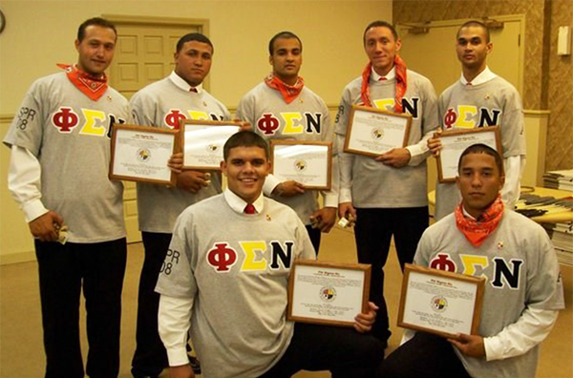
Alpha Chapter, Pi Class
Rho Class, Fall ’08
- Caleb Locklear
- William “AJ” Oxendine
- Taylor Deese
- Nick Locklear
- Kameron Locklear
- Corey Cooper
- Blake Smith
- Marcus Deese
- Kedrick Chavis
- Dimitrios Hunt
Sigma Class, Spring ’09
- Douglas Taylor
- Chaz Cooper
- Ethan Patrick
- Nick Richardson
- Dustin Sutherland
Tau Class‚ Spring ’10
- Matthew Locklear
- Johnathan Jones
Upsilon Class‚ Fall ’11
- Brandon Chavis
- Seth Cooper
- Victor Dial
- Daniel Harris
- Andrew Jacobs
- Branson Locklear
- Preston Locklear
- Jarrod Lowery
- Brantley Oxendine
- Dustin Scott
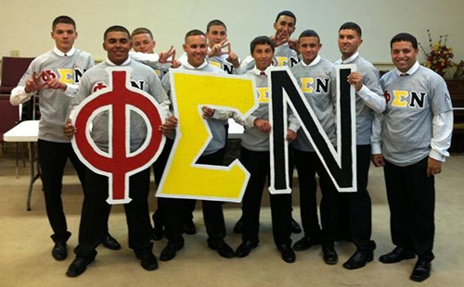
Alpha Chapter – Upsilon Class
Phi Class, Fall ’12
- Andy Brayboy
- Ryan Bullock
- Jordan Deese
- Trae Griffin
- Jarred Jacobs
- Casey Locklear
- Tellar Locklear
- Chris Lowery
- Randall Negrampa
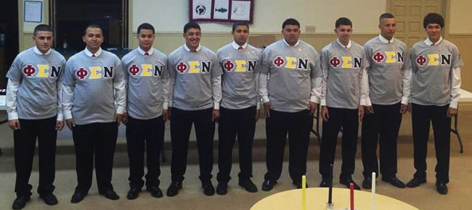
Alpha Chapter – Phi Class
Chi Class, Fall ’13
- Tyler Baker
- Cole Griffin
- Tre Lowry
- James Rudd
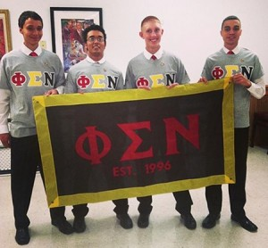
Alpha Chapter – Chi Class

Psi Class, Fall ’14
- Tyler Blue
- Jordan Hunt
- Seth Hunt
- Bracy Malcolm
- Matthew Oxendine
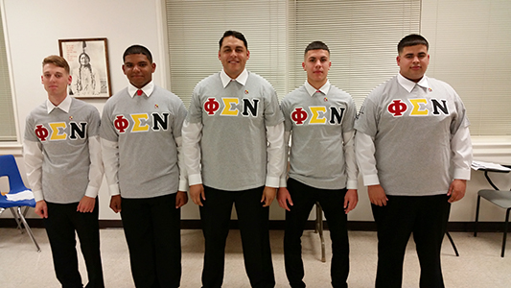
Alpha Chapter – Psi Class
Omega Class, Fall ’15
- Bryan De’Cota Hunt
- Byron Jeffery Hunt
- Seth Emmanuel Jacobs
- David Carson Locklear
- Jacob Seth Locklear
- Antonio Miguel Massol
- Phoenix Emmanuel Maynor
- Mark Hunt Richardson
- Anthony Lynn Williamson
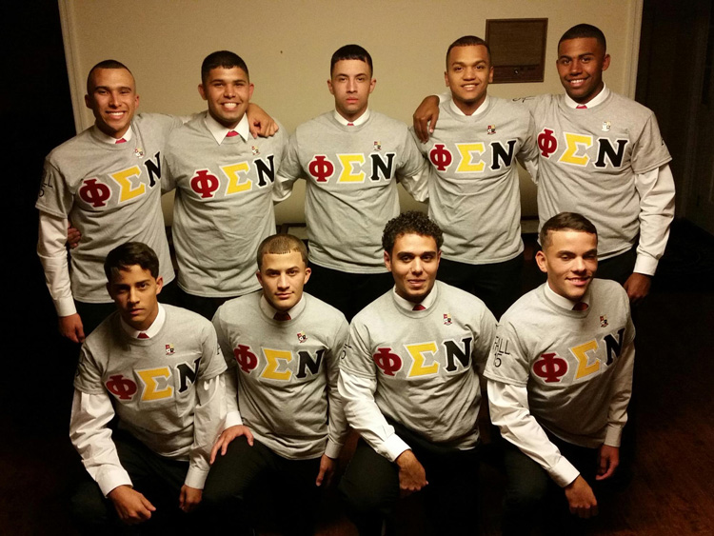
Alpha Chapter – Omega Class
Alpha Alpha Class, Spring ’16
- Troy Darnel Hunt
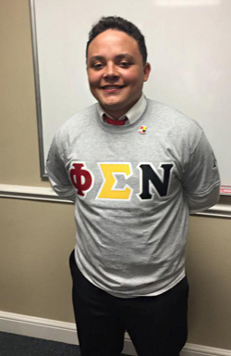
Alpha Chapter – Alpha Alpha Class

Alpha Beta Class, Fall ’17
- Zackary Kay Hunt
- Colton Allen Oxendine
Alpha Gamma Class, Spring ’18
- Ethan Cole Oxendine
- Jamison Alex Deese
Alpha Delta Class, Summer ’18
- Christopher Cameron Richardson
- James Devon Hunt
Alpha Epsilon Class, Fall ’18
- Jeremy Lynn Hunt
- Joshua Caleb Hunt
- Jahvon Anthony Maher
- Jorden Nicholas Revels
Alpha Zeta Class, Fall ’19
- Colby Dale Locklear
- Jayden Waya Locklear
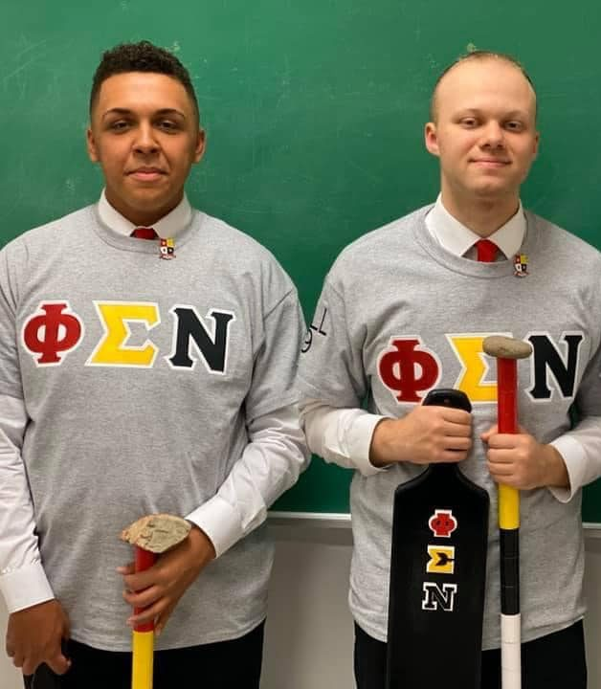
Alpha Chapter - Alpha Zeta Class
Alpha Eta Class, Spring ’20
- Sonny Lynndell Walton
Alpha Theta Class (Chapter)/Alpha Class (National), Spring ’21
- Lucas Nashobe Lynch
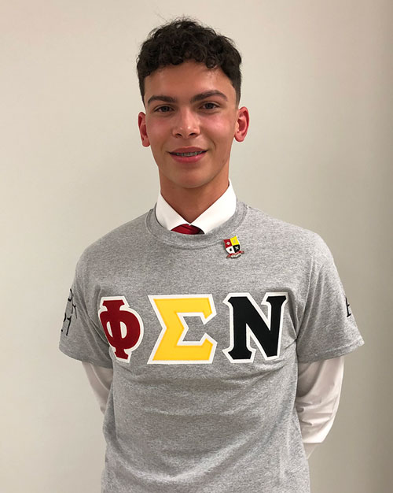
Alpha Chapter- Alpha Theta Class

Alpha Iota Class, Spring ’22
- Coleman Shane Bartley
- Harlan Chavis Jr.
- Benjamin Christopher Clark
- Noah Henry Oxendine
- Adam Kerns Strickland
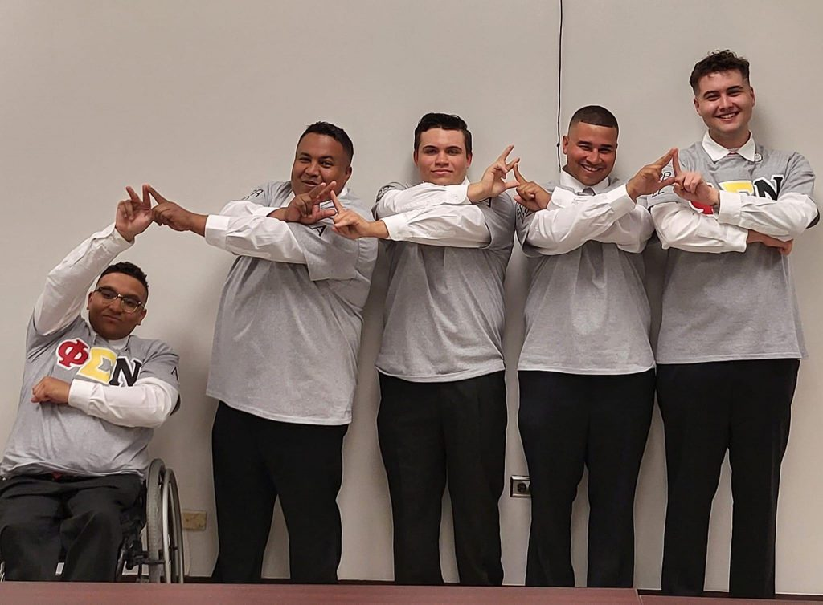
Alpha Chapter - Alpha Iota Class
Alpha Kappa Class, Fall ’22
- Jeremy Black Hunt
- Caleb Matthew Locklear
- Ahelayus Pavlos Oxouzidis
Alpha Lambda Class, Spring ’23
- Austin Isaiah Chavis
- Seth Michael Rogers

Alpha Mu Class, Fall ’23
- Bobby Dale Barsh Jr.
- Haynes Ayden Graham
- Nathanael Trenton Jones
- Markus Kamen Lowery
Alpha Nu Class, Spring ’24
- Kenneth Wayne Jones
- Asa Jeremiah Locklear
- Marcus Landon Lowry
Alpha Xi Class, Fall ‘24
- Grayson Lee Jacobs
- Levi Nathaniel Zickafoose
Alpha Omicron Class, Spring ‘25
- Jacob Benjamin Worriax

Beta Chapter

North Carolina State University
Chartered April 18, 2001

Contact Beta Chapter
- To contact Beta Chapter, email beta@phisigmanu.com.

Chapter Lineage

Charter Class, Spring ’00
- Adam Clark
- Jason Locklear

Alpha Class, Fall ’00
- Jonathan Hunt

Beta Class, Spring ’01
- Justin Chavis

Gamma Class, Fall ’02
- Tony Richardson

Delta Class, Spring ’05
- Brad Lowery

Epsilon Class, Fall ’05
- Travis Blanks
- Adam Jacobs
- Jonathan Oxendine

Zeta Class, Fall ’06
- Ian Bullard
- George Locklear

Eta Class, Fall ’07
- Bradley Holland
- Edwin Roman

Theta Class, Spring ’09
- Ryan Barnett
- Kerwin Chavis
- David Hunt
- Jordan Hunt
- Roger Locklear
- Traver Mayfield

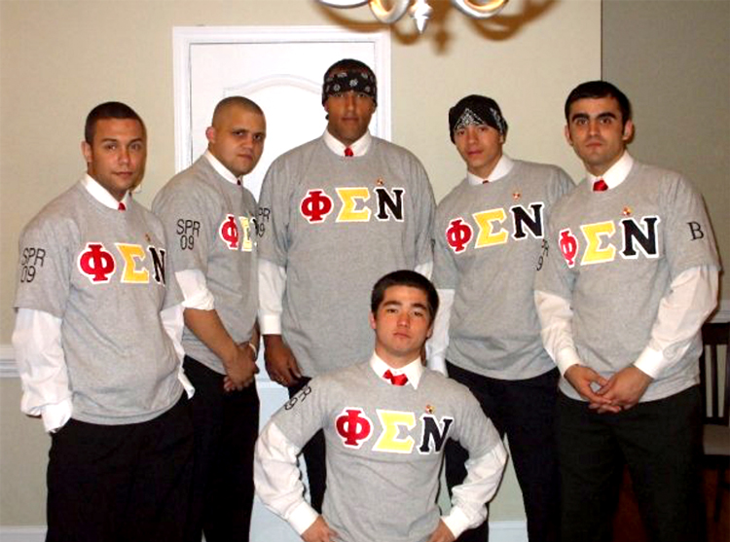
Beta Chapter - Theta Class

Iota Class, Fall ’09
- Joshua Bryant
- David Goins
- Brett Hunt
- Deon Hunt
- Jonathan Locklear
- Joshua Locklear
- Austin Mcphail
- Lee Tropp

Kappa Class, Fall ’10
- Jim Locklear

Lambda Class, Fall ’12
- Juan Carlos Santiago
- Robin Lowery
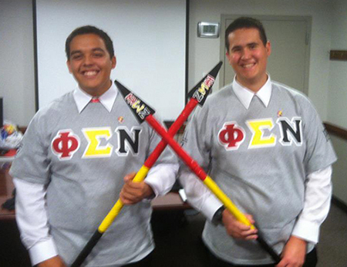
Beta Chapter – Lamba Class

Mu Class, Spring ’14
- Jacob Jacobs
- Austin Lowry
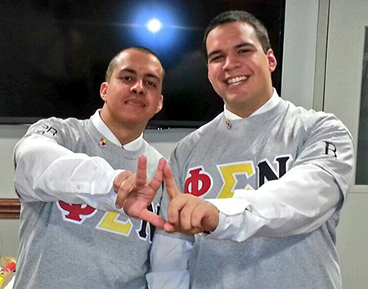
Beta Chapter – Mu Class

Nu Class, Fall ’17
- Kolby Clark
- Isaiah Maher
- Justin Richardson
- Belton Moore
- Liam Locklear
- Elijah Carter

Xi Class, Fall ’19
- LaRon Vince Locklear

Omicron Class (Chapter)/Alpha Class (National), Spring ’21
- Nathan Tate Campbell
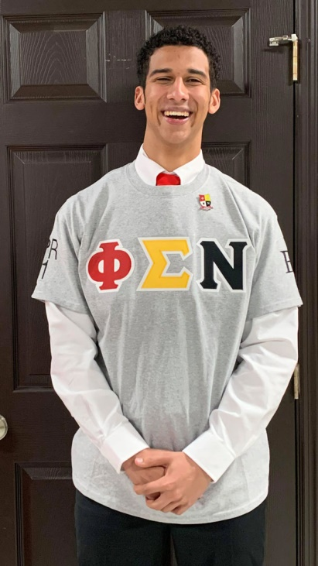
Omicron Class – Beta Chapter

Pi Class, Spring ’22
- Grayson Lee Hunt
- Collin Seth Richardson

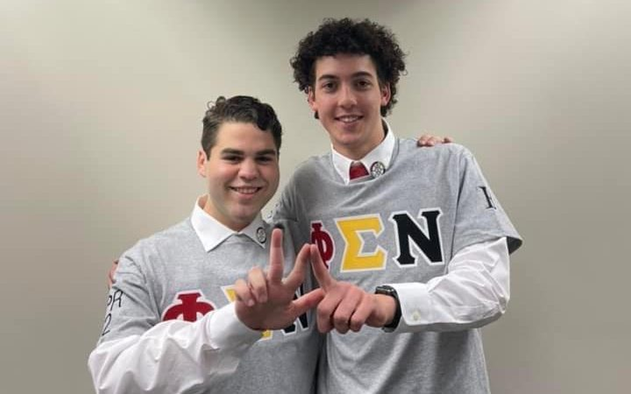
Beta Chapter – Pi Class

Rho Class, Fall ’23
- Andrew Brice Chavis
- Isaac Jacob Evans

Sigma Class, Fall ‘24
- Christopher Matthew Evans

Gamma Chapter
University of North Carolina at Chapel Hill
Chartered October 31, 2003
Contact Gamma Chapter
- To contact Gamma Chapter, email gamma@phisigmanu.com.
Chapter Lineage
Charter Class, Spring ’02
- Eric Blue
- Eric Mitchell
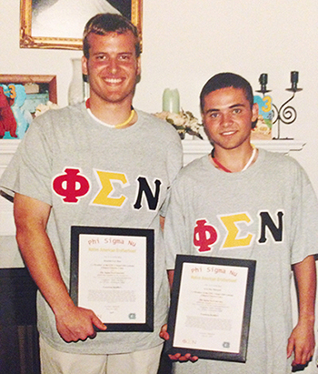
Gamma Chapter – Charter Class
Alpha Class, Spring ’03
- Johnathan Graham
- Derek Oxendine
Beta Class, Spring ’05
- Joshua Barton
- Andrew Bullard
- Matt Locklear
Gamma Class, Spring ’07
- Shane Locklear
- Trevor Locklear
Delta Class, Spring ’08
- Coty Brayboy
- Mickey Bullard
Epsilon Class, Fall ’09
- Earnest Dial
- William Morgan
- Jeremy Locklear
- AC Locklear
- Josh Ransom
- Philip Stacks
Zeta Class, Fall ’11
- Jordan Jones
- Christopher Spaulding
Eta Class, Spring ’14
- Marcus Collins
- Tommie Chavis
- Jordan Jacobs
- Harley Devon Locklear
- Joseph Evander Locklear
- Quentin Tatum Locklear
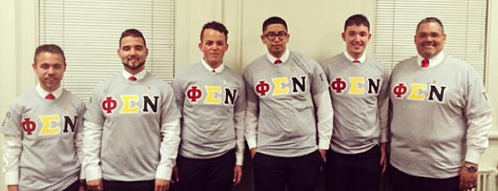
Gamma Chapter – Eta Class
Theta Class, Spring ’17
- Gavin Levine Bell
- Timothy Black Hite
- Garrett Melvin Locklear
- Jamison Dean Lowery
- Nijal Jarrel Morgan
- Stephen Ryan Stanley
- James Ennis Street
Iota Class, Spring ’18
- Taner Kylan Jacobs
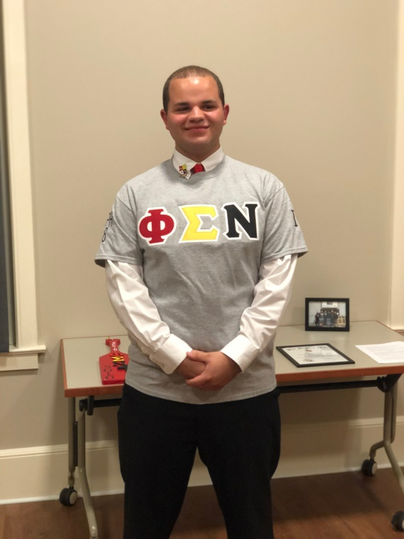
Iota Class – Gamma Chapter
Kappa Class, Fall ’19
- Jakob Jackson
- Zachary Richardson
Lambda Class, Fall ’21
- Elson Ray Hunt
- Frederick Dalton Locklear
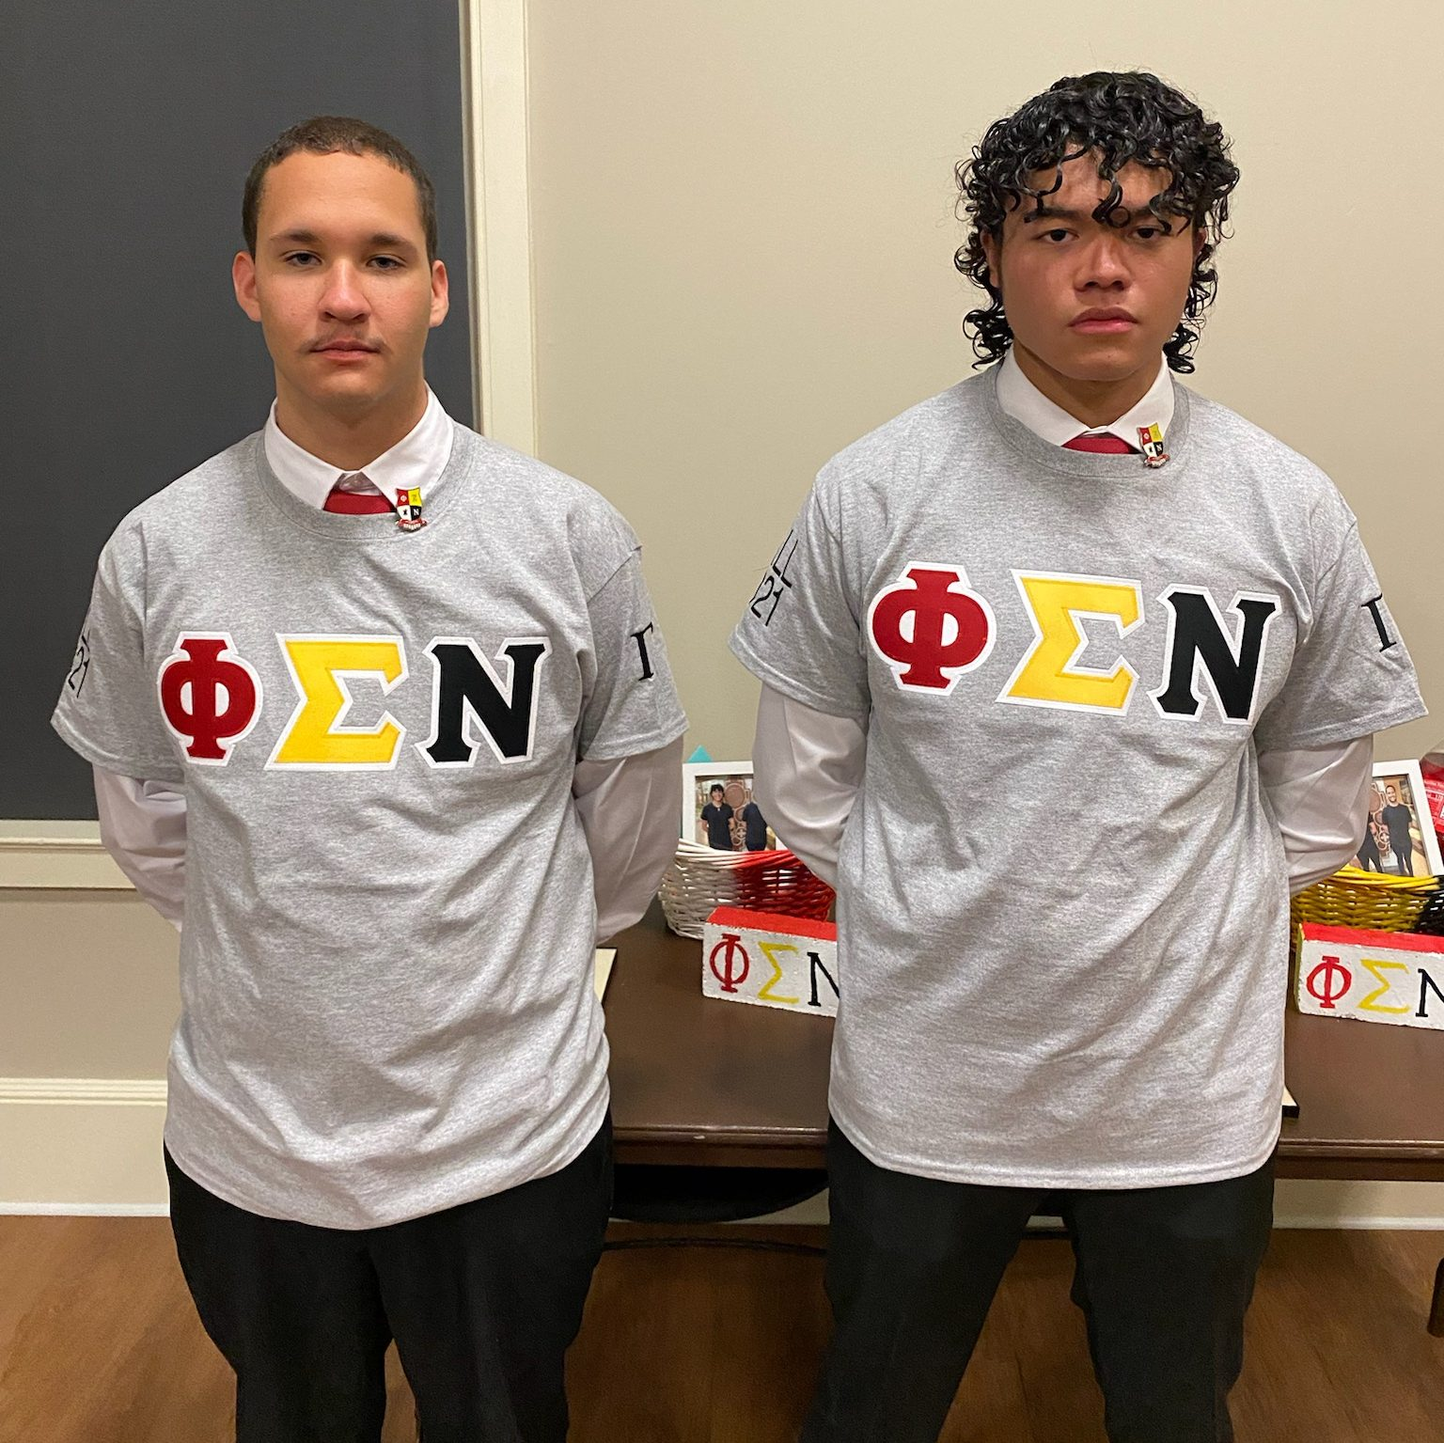
Gamma Chapter - Lambda Class
Mu Class, Fall ’23
- Cayden Michael Hammonds
- Dylan Kenai Hammonds

Delta Chapter
Oklahoma State University
Chartered April 2, 2006
Contact Delta Chapter
- To contact Delta Chapter, email delta@phisigmanu.com.
Chapter Lineage
Charter Class, Spring ’05
- Thomas Bezinque
Alpha Class, Spring ’06
- Michael Henry
- Casey Bear
- Greg Marris
- Robert Conrad
- Paskova Deere
- Dillon Moore
- Doran Jackson
Beta Class, Fall ’06
- Nathan Wood
Gamma Class, Fall ’09
- Kevin Wells
- Nick Liew
- Michael Keller

Delta Class, Spring ’13
- Jaycee Haff
- Alex Hardison
- James Jump
- Larod Snyder
- Keenan Springer
- Logan Welge
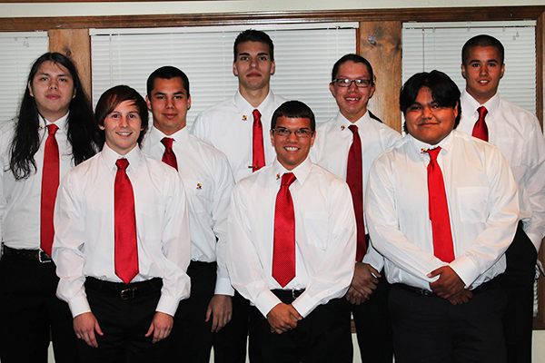
Delta Chapter (Delta Class) and Epsilon Chapter (Lambda Class) Joint Intake

Epsilon Class, Fall ’15
- Curtis Jump
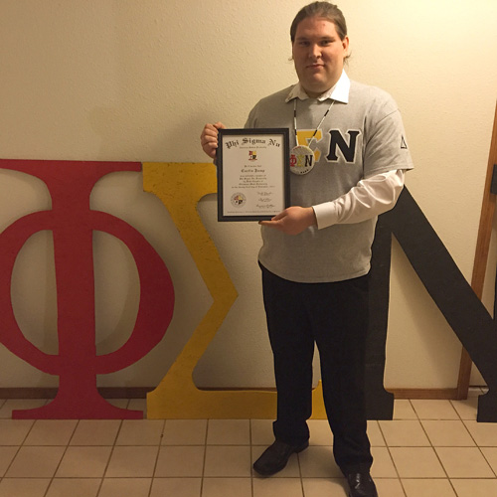
Delta Chapter – Epsilon Class
Epsilon Chapter
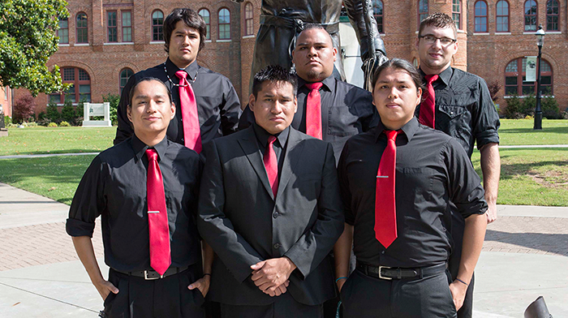
Epsilon Chapter – 2014 Chief Convention
Northeastern State University
Chartered April 22, 2006
Contact Epsilon Chapter
- To contanct Epsilon Chapter, email epsilon@phisigmanu.com.
Chapter Lineage
Charter Class, Spring ’06
- Darcy Medicine Horse
- Kellen Palmer
- Stephn Drywater
- Daniel Landeverde
- Sonny Hawk
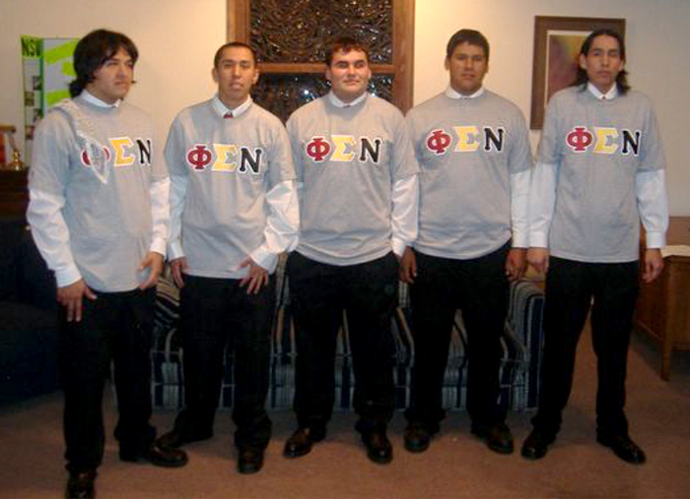
Epsilon Chapter – Charter Class
Alpha Class, Spring ’07
- Alan Colbert Jr.
- Cory Jimboy
- Eric Marshall
Beta Class, Fall ’07
- Zach Mayhew
- Shane Shumake
Gamma Class, Fall ’08
- James Cosby
Delta Class, Fall ’09
- JC Lowe
- Jeremy Doublehead
- Isaiah Soap
- Hyde Toppah
- Russell Harjo
- Julius Black
- Jaxin Enemy-Hunter
Epsilon Class, Spring ’10
- Shu Nakai
- David Gionta
- Cody Evans
- Neka James
Zeta Class, Fall ’10
- Yuki Uetsu
- Paul Martinez
- Travis Wolfe
Eta Class, Spring ’11
- Philip Curry
- Michael Landrum
- Ronnie Checotah
Theta Class, Fall ’11
- Daniel Jackson
- Tyler Joines
- Devin Potts
- Daniel Roberts
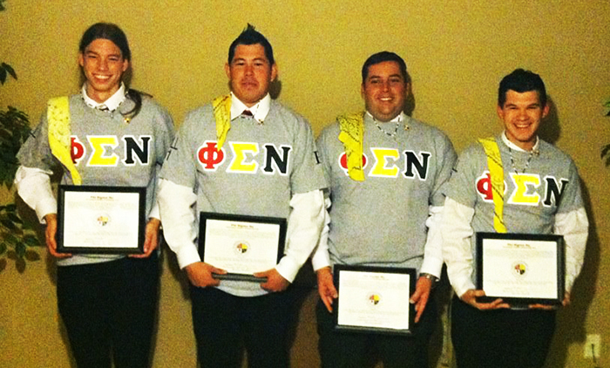
Epsilon Chapter – Theta Class
Iota Class, Spring ’12
- Taylor Sanders
- Orrin Hoffman
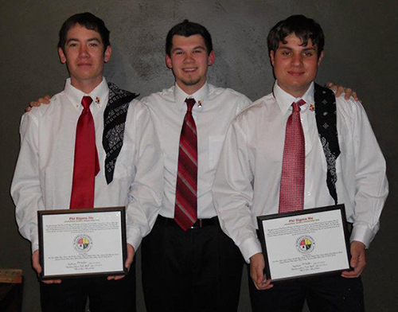
Epsilon Chapter – Iota Class
Kappa Class, Fall ’12
- Lucas Coats
- Jason Denny
- Jacob Goodrich
- Geoff Little
- Joshua Mease
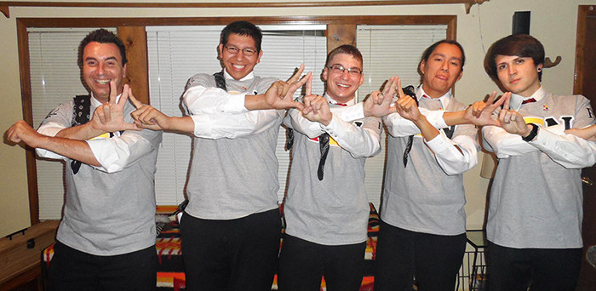
Epsilon Chapter – Kappa Class
Lambda Class, Spring ’13
- Taylor Goodrich
- Nicholas McElhaney
Delta Chapter (Delta Class) and Epsilon CHapter (Lambda Class) Joint Intake
Mu Class, Spring ’14
- Paxton Moore
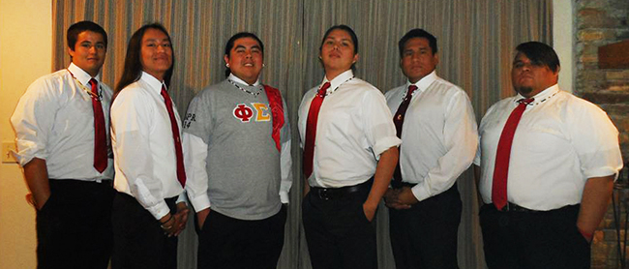
Epsilon Chapter – Mu Class
Nu Class, Spring ’15
- Samuel Frazier
- Austin Ware
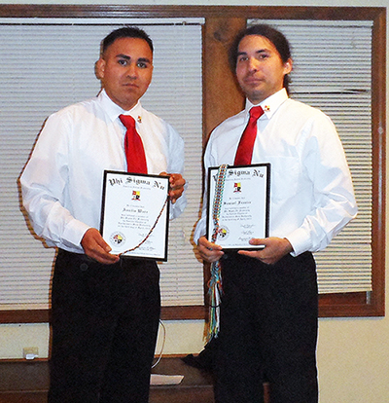
Epsilon Chapter – Nu Class
Xi Class, Fall ’15
- Jacob Esai Chaves
- Jobie Reyes Grayson
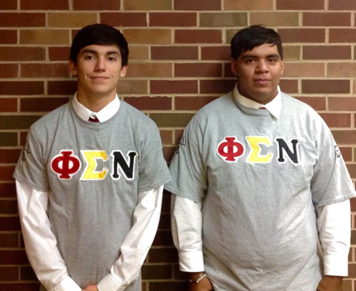
Epsilon Chapter – Xi Class
Omicron Class, Spring ’17
- Trey Pritchett
- Skylar Vann
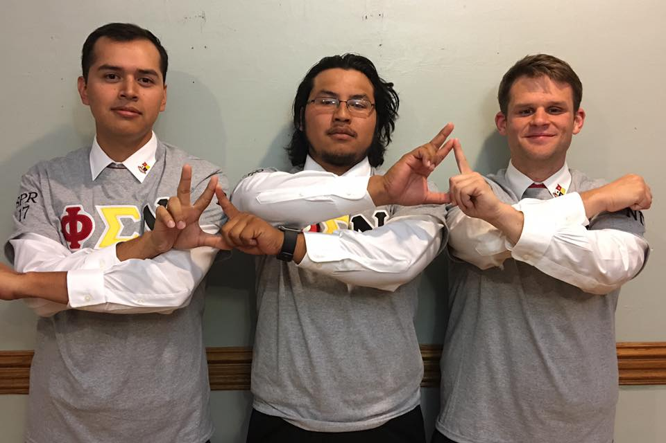
Epsilon (left and center) and Nu Gamma (right) Spring 17 Class

Pi Class, Fall ’18
- Christian Anderson
- Elijah Girty
- Cody Poindexter
Rho Class, Spring ’19
- Christian Rangel
- Luke Wassom

Zeta Chapter
Arizona State University
Chartered November 1, 2007
Contact Zeta Chapter
- Coming soon!
Chapter Lineage
Charter Class‚ Fall ’07
- Cheston Bailon
- John Bailon
- Leroy Begay
- Kevin Bitsie
- Zach Bitsuie
- Carlos Clark
- Jasper Henry
- Kyle Huskey
- Tremayne Scott
- William Thompson
- Shayne Watson
- Derreck Wheeler
Alpha Class‚ Spring ’08
- Waddie Jones
- Erik Schierholz
- Lane Thomas
Beta Class‚ Fall ’08
- Donovan Barney
- Edward Dawahoya
Gamma Class‚ Fall ’09
- Youveal Begaye
- Cody Carlston
- Ryan Etsitty
- Lyle Francis
- Damien Lee
- Martin Manuel
- Michael Martin
- Loren McCabe
- Lance Reyna
Delta Class‚ Fall ’10
- Lionel Yellowhair
- Wacey Francisco
- Derek Wesley
- Leiander Benally
Epsilon Class, Fall ’12
- Cory Charly
- Kyle Carlston
- Brandon Begay

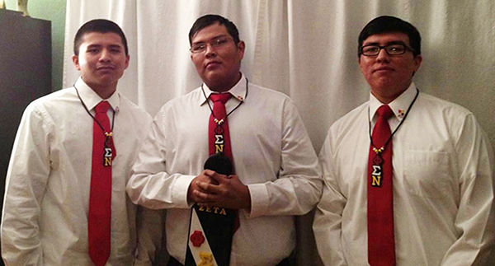
Zeta Chapter – Epsilon Class

Eta Chapter
University of North Carolina at Charlotte
Provisional (inactive)
Charter Class, Fall ’11
- Zachary Correy Bullard
- Tate Young
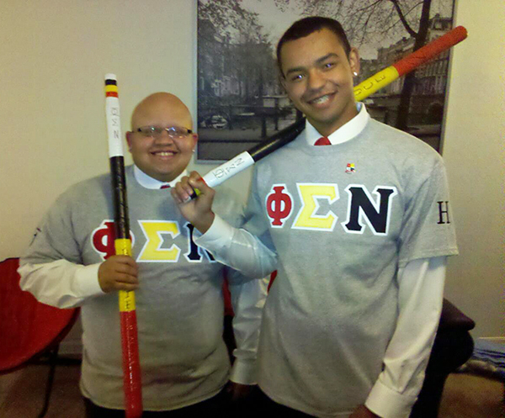
Eta Provisional Chapter – Charter Class

Alpha Class, Spring ’12
- Raymond Deese
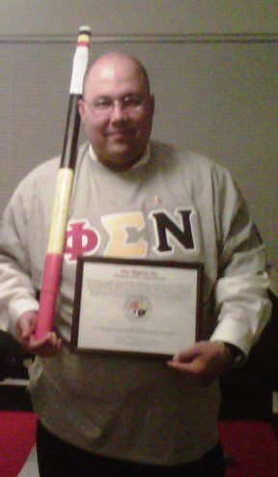
Eta Provisional Chapter – Alpha Class

Theta Chapter

New Mexico State University
Provisional (inactive)

More information coming soon!

Iota Chapter
Haskell Indian Nations University
Chartered April 1, 2014
Contact Iota Chapter
- Coming soon!
Chapter Lineage
Charter Class‚ Spring ’12
- Ryan Coody
- Joel Hernandez
- Brian Johnson
- Curt Pahmahmie
- Ian Stand
- Philip Stand
- Joshua Weston
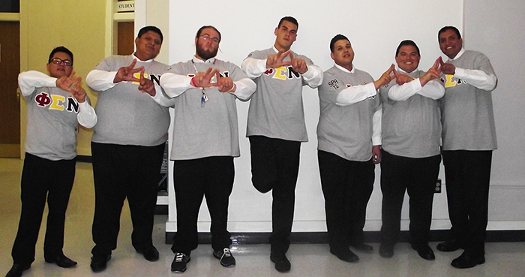
Iota Chapter – Charter Class
Alpha Class‚ Fall ’12
- Nicholas Crisp
- Julio Dehose
- Michael Garcia
- David Henry
- Peter Henry
- Scott Labrie
- Calvin Martinez
- BJ Moses
- Winston Robison
- Daniel Tanner
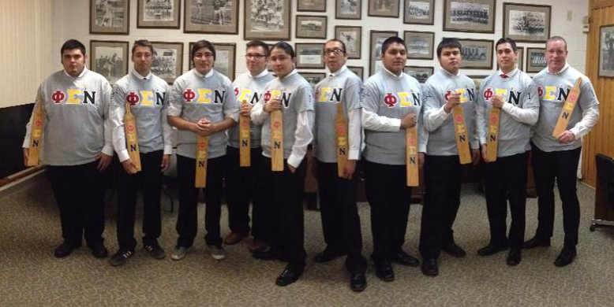
Iota Chapter – Alpha Class
Beta Class‚ Spring ’13
- Robert Castellanos
- Dion John
- Alex McCosar
- Ronald Rousseau
- Anthony Taylor
- Thomas Wilson
Gamma Class‚ Fall ’13
- Justin Bauswell
- Travis Campbell
- Harlen Harvey
- Michael Jim
- Shane Sanderson
- Anthony Tarin
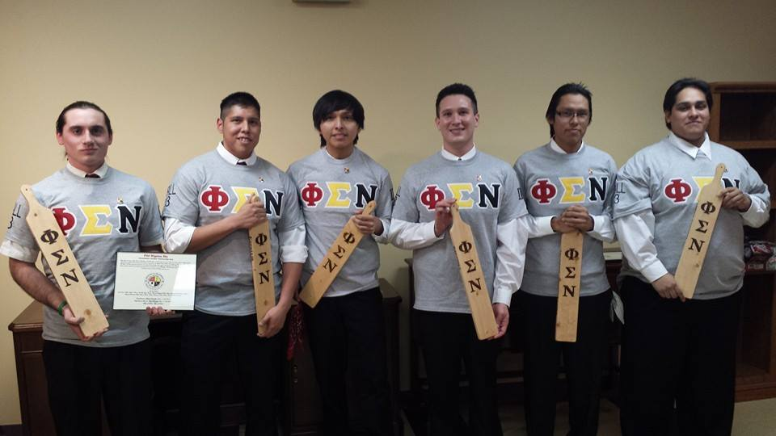
Iota Chapter – Gamma Class
Delta Class‚ Spring ’14
- Hussien Aspaas-Montoya
- Samuel Byers
- Brenden LaVallie
- Ray Phillips
- Alexander Rodriguez
- Gabriel Good Shield
- Allen R Stephenson
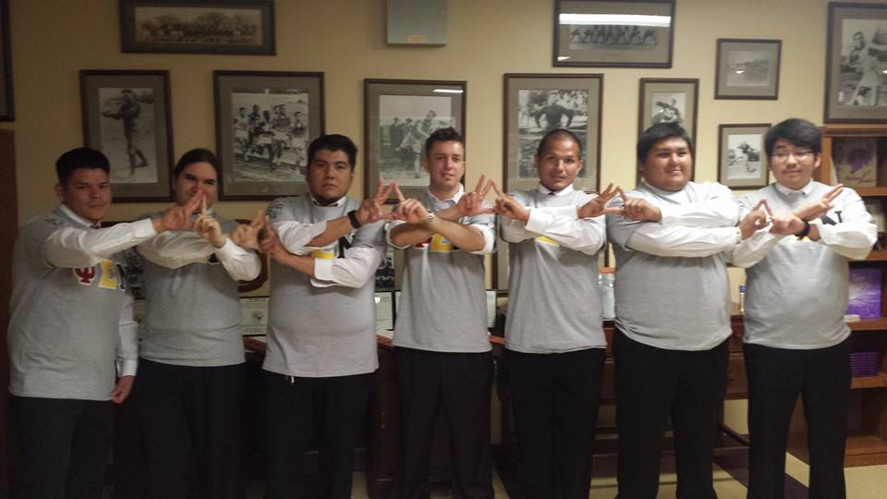
Iota Chapter – Delta Class
Epsilon Class, Fall ’14
- Jake Chino
- Sloan Cloke
- Benton Cooksey
- Samuel Fraley
- James Giago
- Kevin Jason Herrera
- Cody Hummingbird
- Kent Little Thunder
- David Waybenais
- Vernon Giles Welch
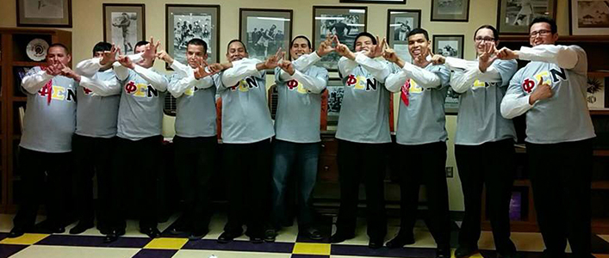
Iota Chapter – Epsilon Class
Zeta Class, Spring ’15
- Timothy C. Buck
- Hunter J. Collins
- Colton S. Lee
- Derrick T. Sleeper
- Joseph T. Tosee
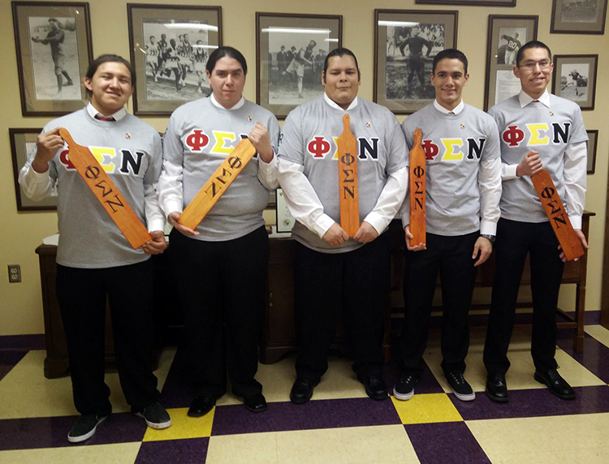
Iota Chapter – Zeta Class
Eta Class, Fall ’15
- Ronald T. Hicks
- Adler G. Montoya
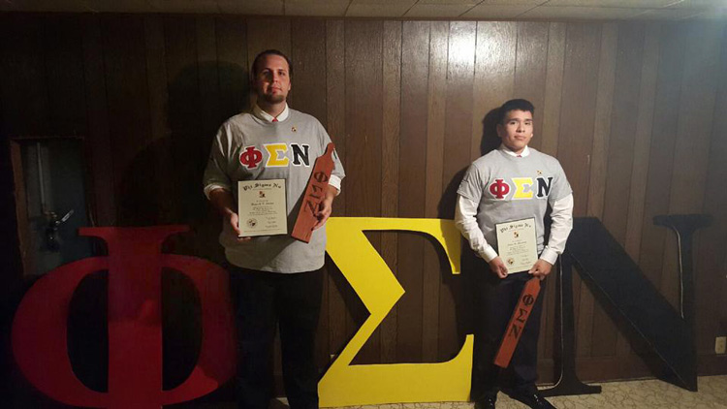
Iota Chapter – Eta Class
Theta Class, Spring ’16
- Whitewolf Geronimo
- Ryan Myore
- Aston Osborne
- Weston L. Smith
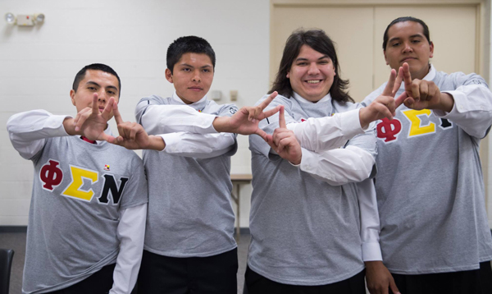
Iota Chapter – Theta Class
Iota Class, Fall ’16
- Jonah Brooks
- Chancelor Jenkins
- Cody Keefer
- James Osborne
- Joshua Posch
- Joshua Richards
- Jalen Tail
Kappa Class, Spring ’17
- Jeremy Attocknie
- Daniel Two Crow
- Johnny Crow
- Warren Griffin
- Jade Lomahaitewa
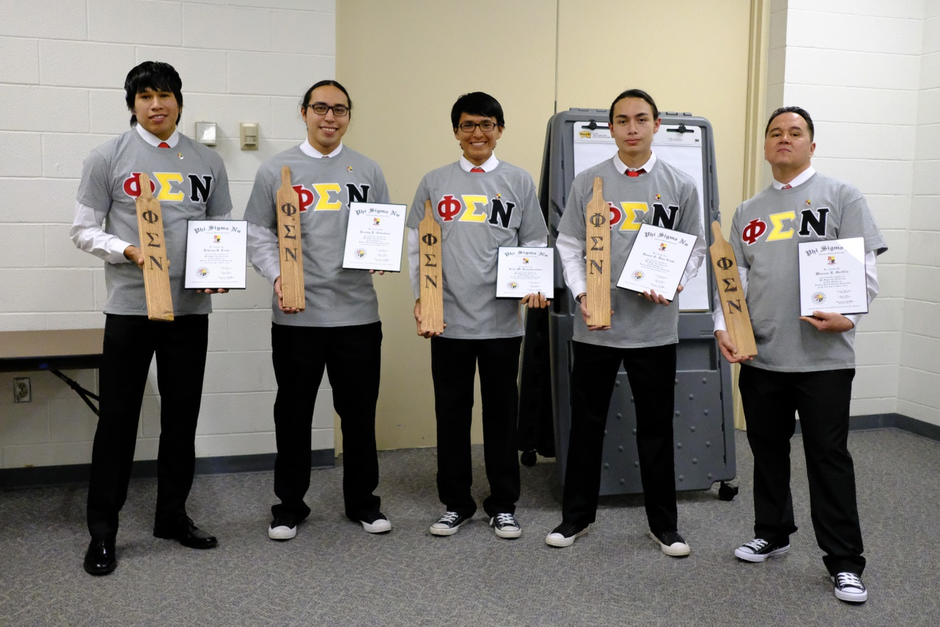
Iota Chapter – Kappa Class
Lambda Class, Fall ’17
- Jake L. White
- Tyler J. Sarrancino
- Montgomery J. Green Jr.
- Michael R.L. Begay
- Rowan R. Lee
- Barry L. Sterling
- Joshua A. Cournover
- Shawney L. Tree Top Jr.
- Justin K. Ennis
- Timothy Denego

Mu Class, Spring ’18
- Johnathon Davidson
- Jevin Durks
- Justin Tso
- Thomas Berryhill Jr.
Nu Class, Fall ’18
- Bradley B. Billy
- William D. Edmo IV
- William “Chase” Heimbecker
- Rodney B. McCoy
- Logan N. Wofford
Xi Class, Fall ’19
- Tyree M. Moore
Omicron Class, Fall ’22
- Dylan L. Arnariak
- Derek M. Begay
- Marcus K. Dogskin
- Grayson T. Dyer
- McGavyne D. Lone Elk
- Alex Manygoats Jr.
- Austin N. Pitzer
- Jaylon E. Romine
- Nicholas T. Yazzie

Pi Class, Spring ’23
- O’rye M. Franklin
- Josiah A. Hill
- Samuel D. LeClair
- Jacob S. Long
- Micah E. Straley
Rho Class, Spring ’24
- Deon Teller
- Troy T. Begay
- Kyle J. Lime
- Matthew D. Billie

Kappa Chapter
Dartmouth College
Provisional
Contact Kappa Chapter
- To contact Kappa Chapter, email kappa@phisigmanu.com.
Chapter Lineage
Charter Class, Fall ’13
- Samuel Black
- Preston Wells
- Matt Wheeler
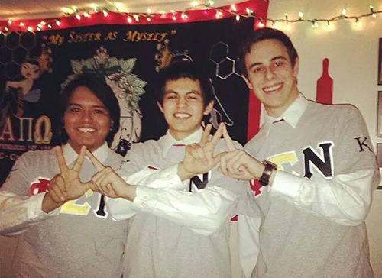
Kappa Chapter – Charter Class
Alpha Class, Spring ’15
- Keenan William Bearskin
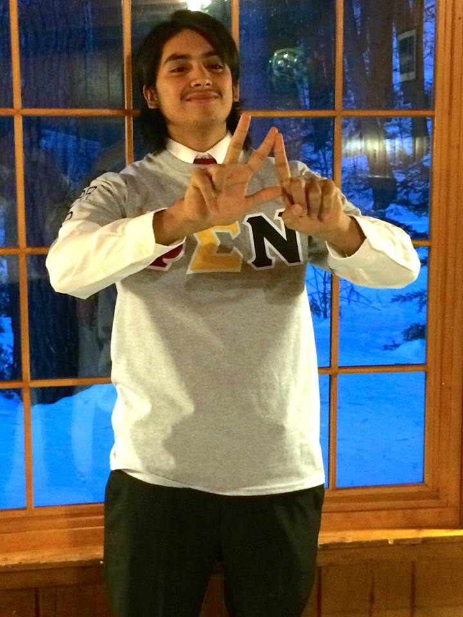
Kappa Chapter – Alpha Class

Lambda Chapter
Southeastern Oklahoma State University
Provisional
Contact Lambda Chapter
- Coming soon!
Chapter Lineage
Charter Class, Spring ’16
- Isaac Parker Elliott
- Anthony Hill
- Tristin Lackey
- Casey Love
- Matt Maxwell
- Payton Whitehead
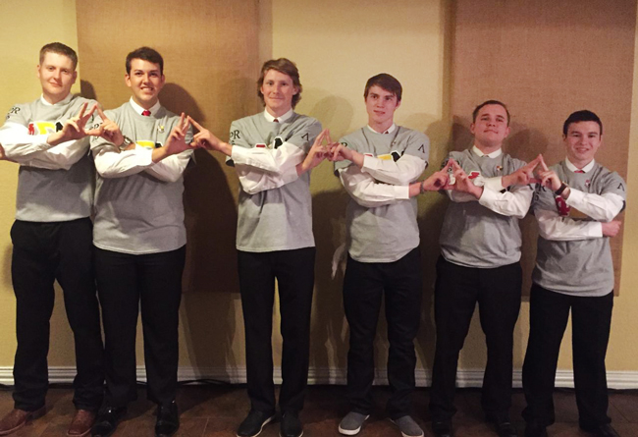
Lambda Chapter – Charter Class

St. Gregory’s University Provisional Chapter
St. Gregory’s University, Shawnee OK
Provisional
Charter Class, Spring ’17
- Phoenix Bills
- Daniel Snow
- Jeffrey Trout
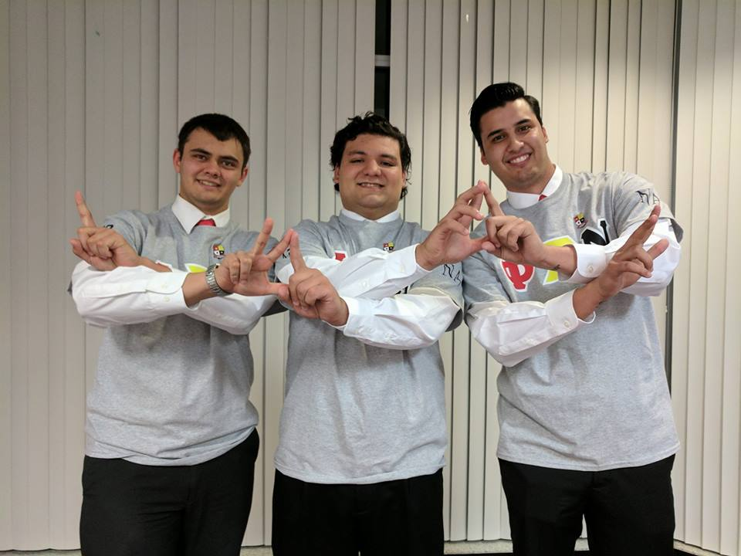
St. Gregory’s – Charter Class

Nu Alpha Chapter
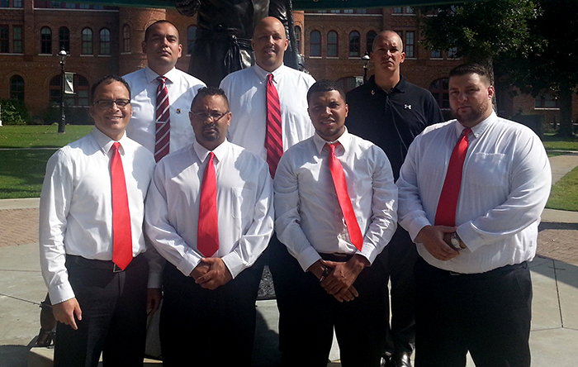
Nu Alpha Chapter – 2014 Chief Convention
State of North Carolina (Professional)
Chartered December 15, 2007
Contact Nu Alpha Chapter
- To contact Nu Alpha Chapter, please email nualpha@phisigmanu.com.
Chapter Lineage
Nu Alpha Chapter - Charter Class, Fall ’07
- Chris Conner
- Steve Hunt
- John Lowery
- Matthew Scott
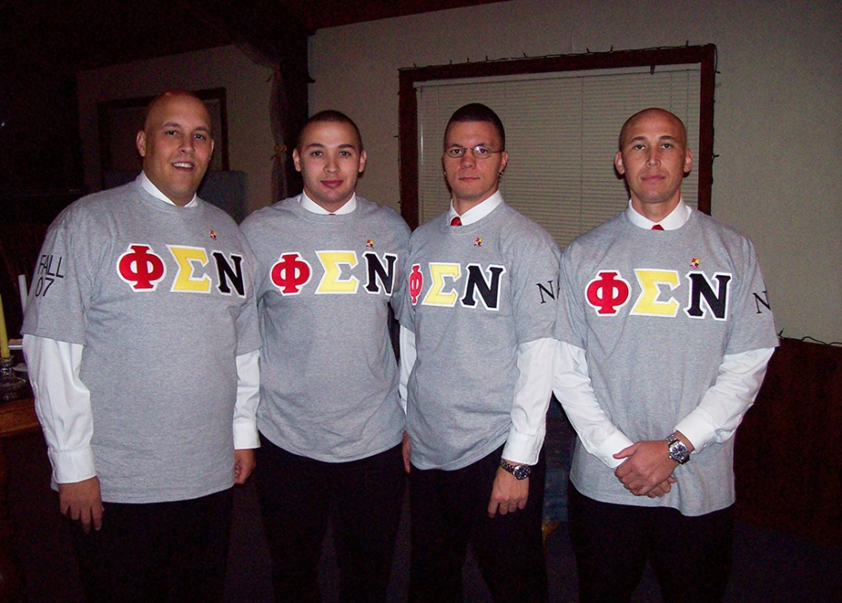
Nu Alpha – Charter Class
Nu Alpha Chapter - Alpha Class, Spring ’11
- Marcus Hunt
- Frank Cooper
- Chad Pierce
- Ian T. Stroud
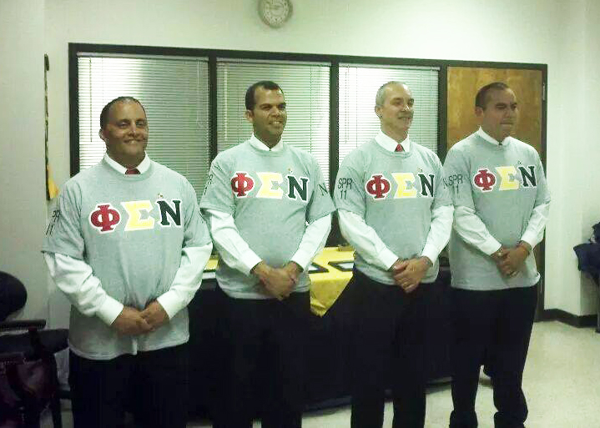
Nu Alpha – Alpha Class

Nu Alpha Chapter - Beta Class, Spring ’14
- Mark Hunt
- Timothy “Tim” Hunt
- Lawrence T. Locklear
- Rocky Locklear
- Kevin Melvin
- Michael Richardson
- Troy Richardson
- Cedric Sunray
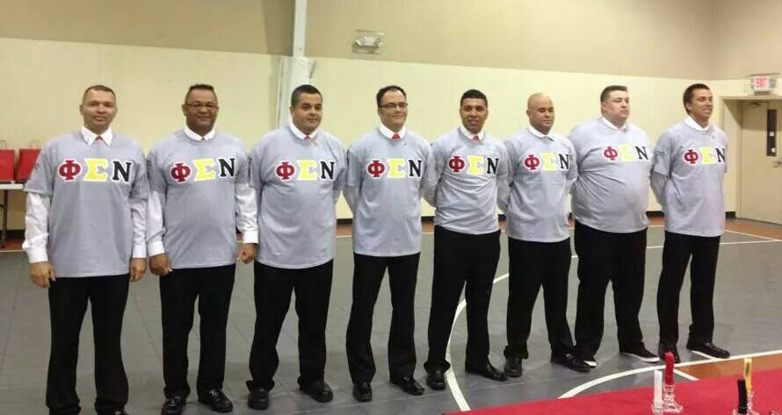
Nu Alpha – Beta Class
Nu Alpha Chapter - Gamma Class, Spring ’16
- Lamonte Boddie
- Christopher Clark
- Robert Redell Dial
- Roger Dean Hunt Jr.
- Sandy Colburn Jacobs
- Mark Wendell Oxendine
- John Wesley Revels III
- Rogers Alphonzo Stephens II
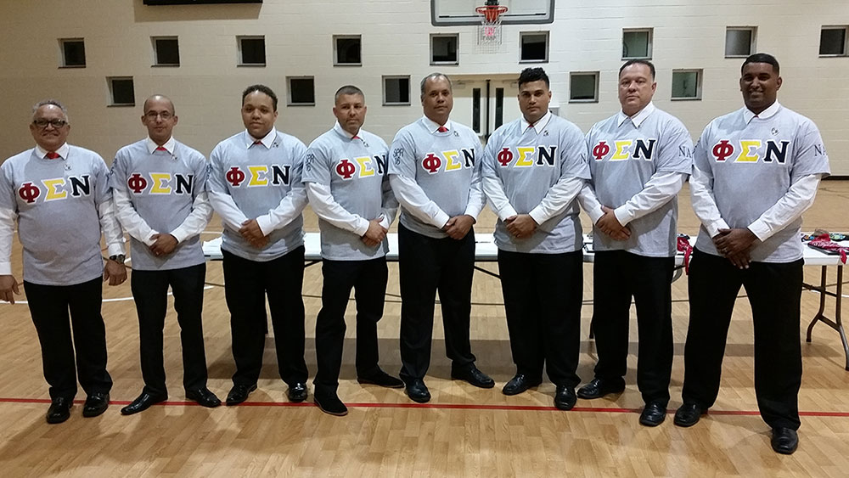
Nu Alpha – Gamma Class
Nu Alpha Chapter - Delta Class (Chapter)/Alpha Class (National), Spring ’21
- Anthony Dwayne Carter
- Mickey Carlyle Jacobs
- Michael Locklear
- Steven Allen Locklear
- Wendel Wayne Locklear
- Jamie Lynn Lowery
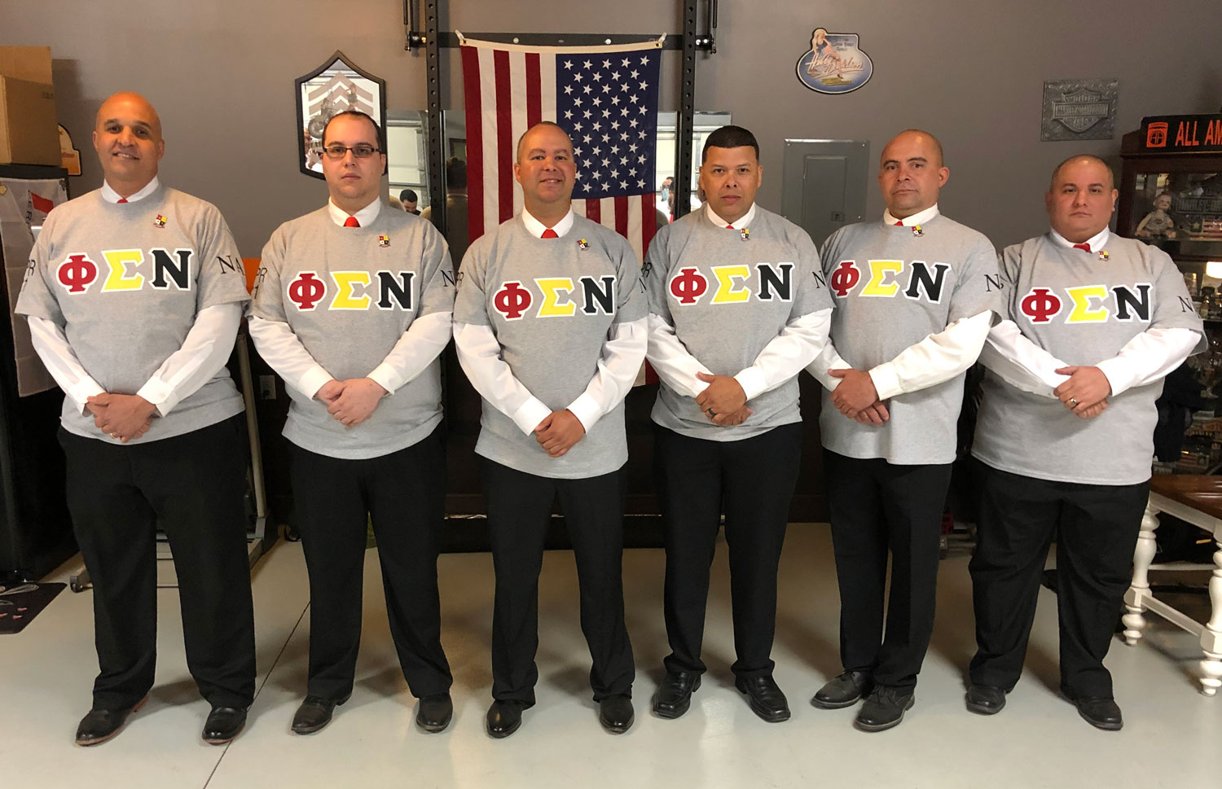
Delta Class – Nu Alpha Chapter
Nu Alpha Chapter - Epsilon Class, Spring ‘25
- McKinley Holloway Richardson

Nu Beta Chapter

State of Kansas
Provisional

Contact Nu Beta Chapter
- To contact Nu Beta Chapter, please email nubeta@phisigmanu.com.
More information is coming soon!

Nu Gamma Chapter

State of Oklahoma
Provisional

Contact Nu Gamma Chapter
- To contact Nu Gamma Chapter, please email nugamma@phisigmanu.com.

Charter Class, Spring ’17
- Billy Flint

Nu Delta Chapter

Research Triangle (North Carolina)
Provisional

Contact Nu Delta Chapter
- To contact Nu Delta Chapter, please email nudelta@phisigmanu.com.
More information is coming soon!

Chapter Omega
Chapter Omega is reserved for Brothers who have passed away and gone to join the Creator.
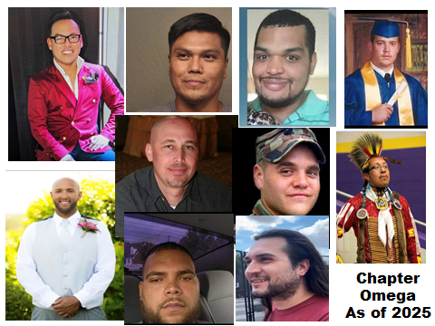

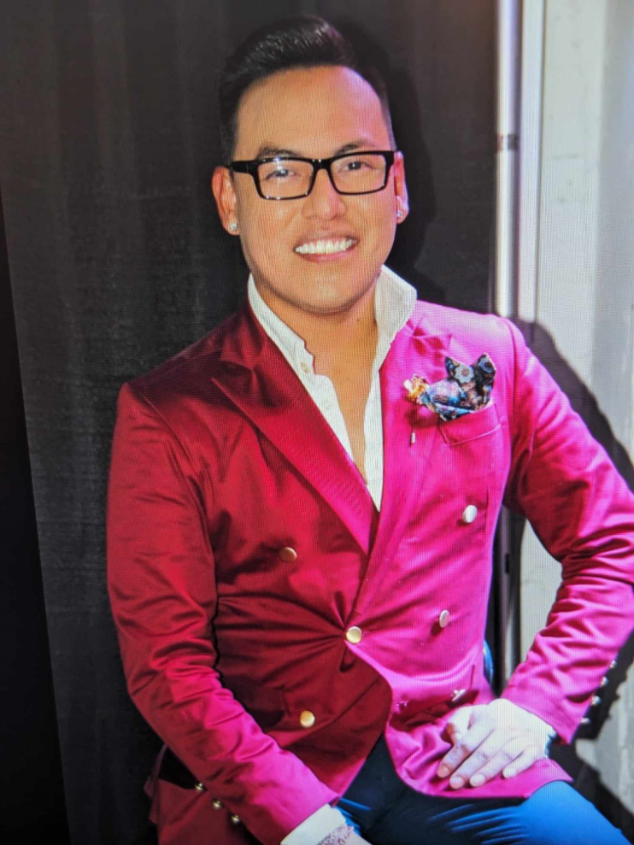
Shayne Watson
Zeta Chapter
Charter Class‚ Fall ’07
August 11, 1987 – November 05, 2023



Kerwin Dewayne Chavis
Beta Chapter
Theta Class, Spring ’09
December 20, 1989 – September 15, 2023

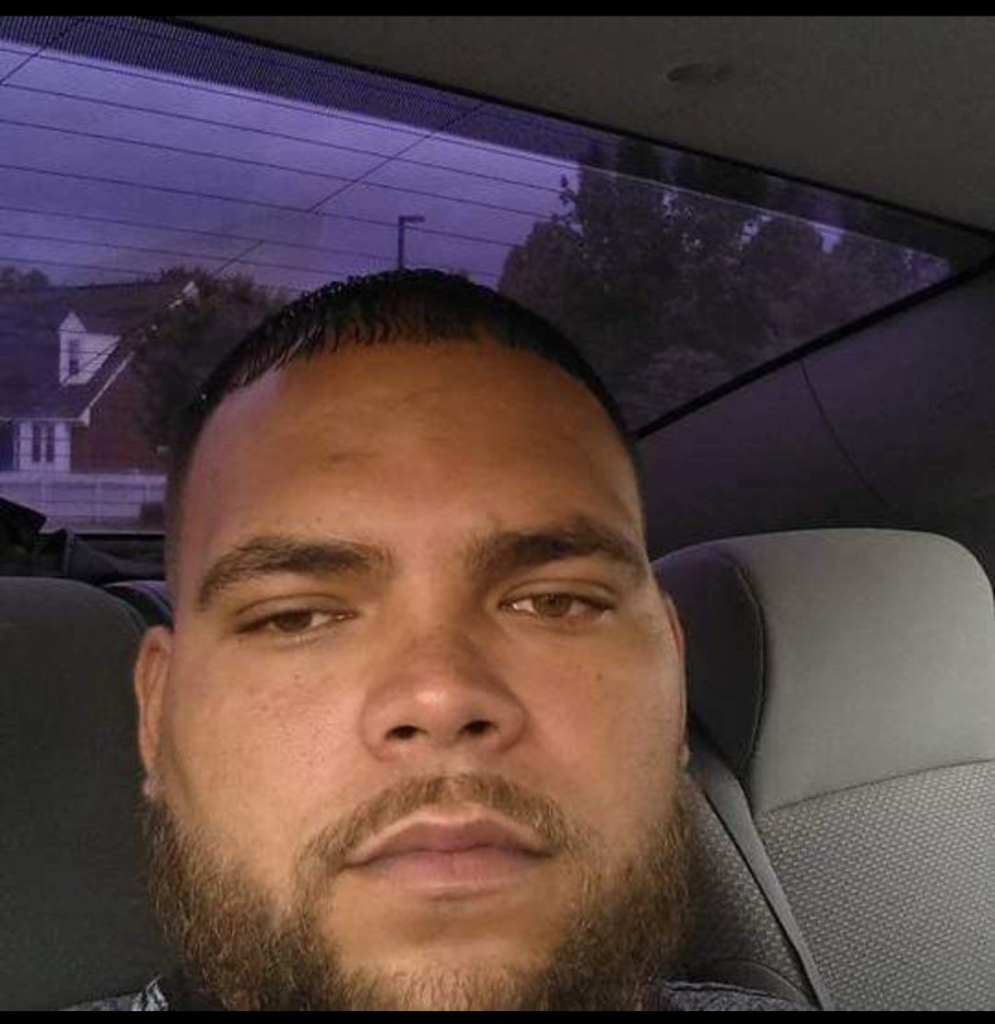
Brandon Michael Godaire
Alpha Chapter
Kappa Class, Fall 2003
August 24, 1985 – August 23, 2023

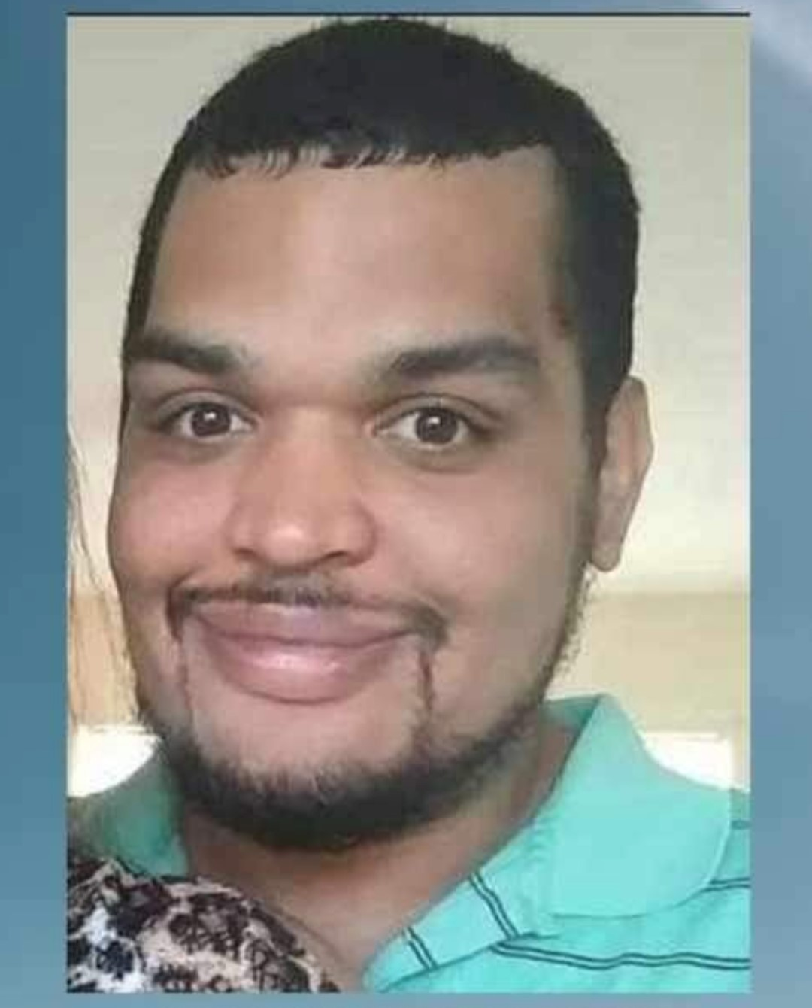
James Reed “JR” Taylor
Alpha Chapter
Mu Class, Fall 2004
September 7, 1986 – July 4, 2023

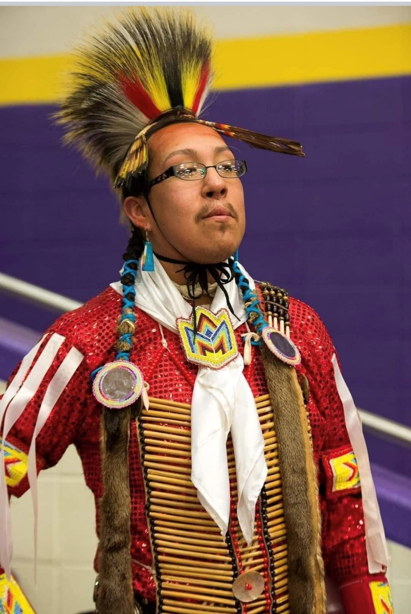
Berwyn “BJ” Moses Jr.
Iota Chapter
Alpha Class, Fall 2012
January 7, 1991 – December 1, 2022

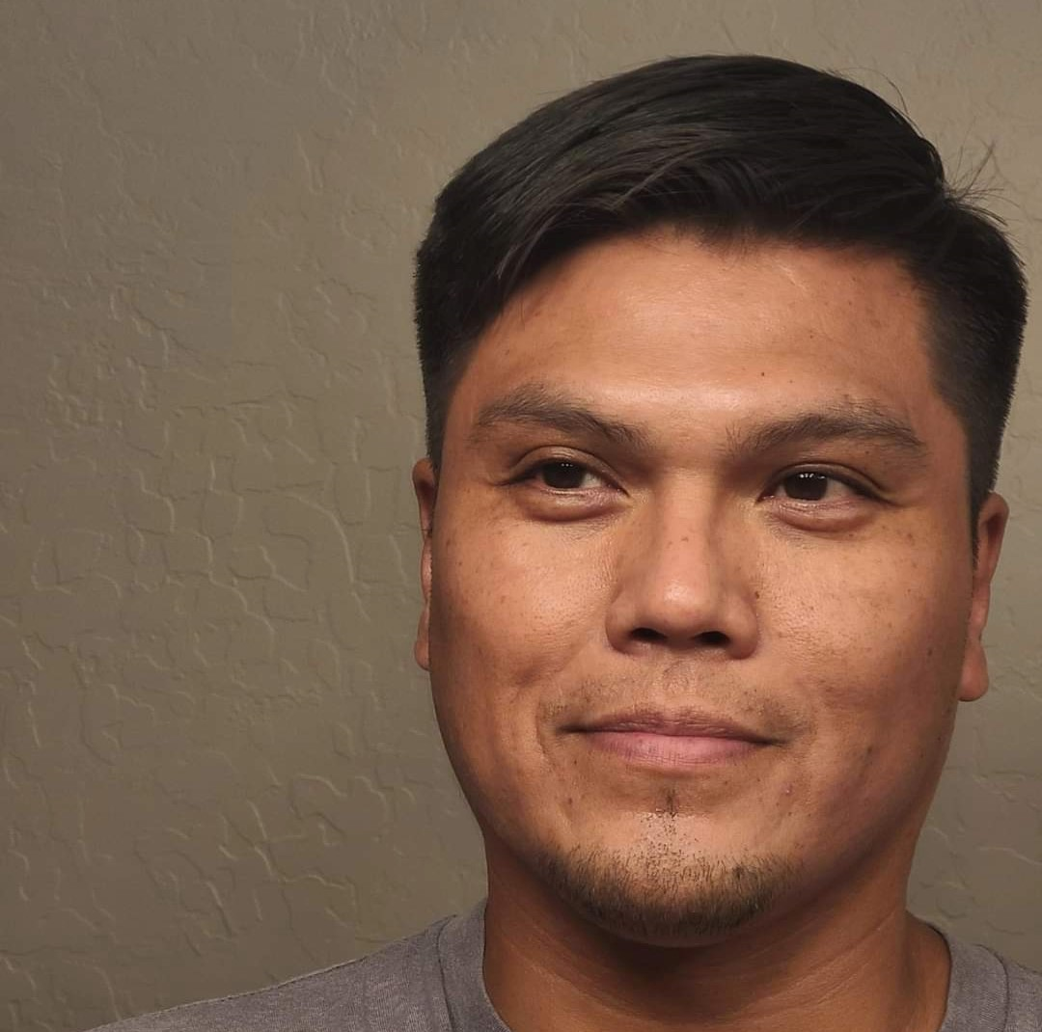
Uval Begaye
Zeta Chapter
Gamma Class, Fall 2009
Passed away 2022

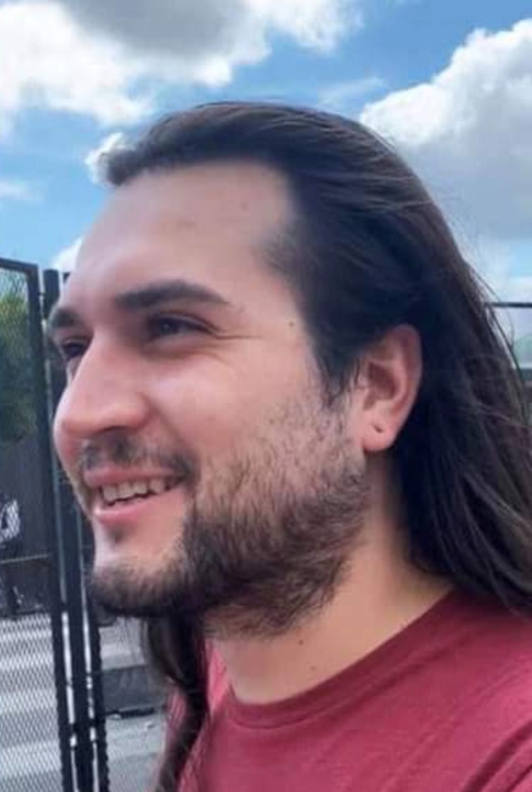
Joshua A. Mease
Epsilon Chapter
Kappa Class, Fall 2012
April 13, 1993 – December 22, 2020
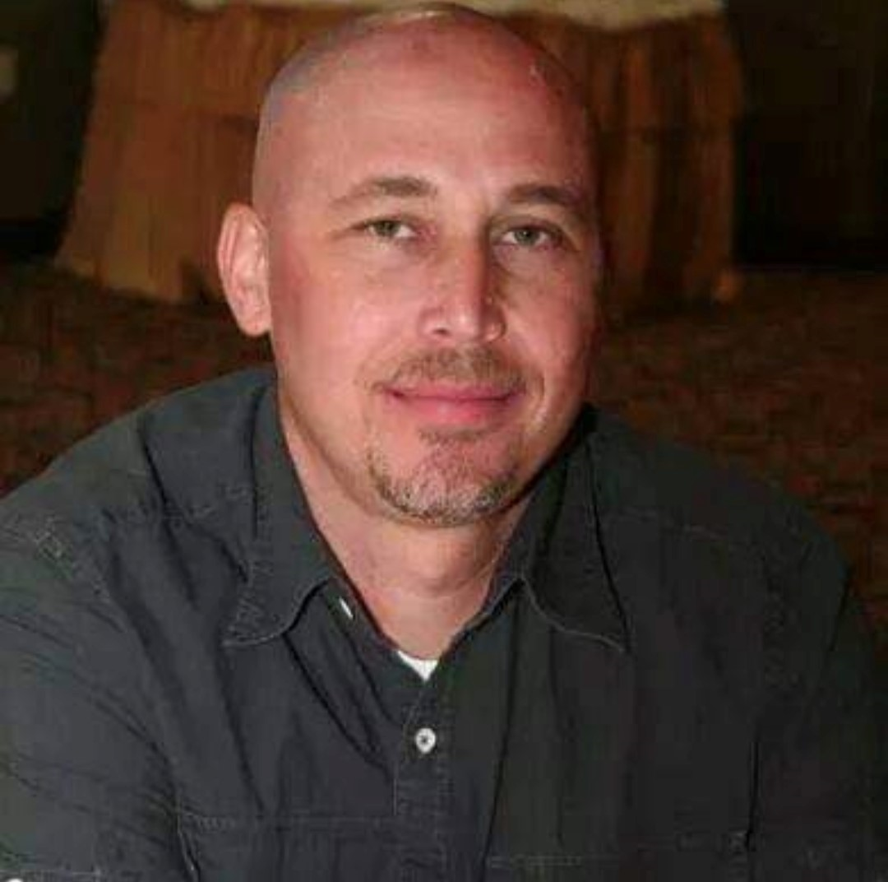
Cpt. Steven A. Hunt “The Bald Man”
Nu Alpha Chapter
Charter Class, Fall 2007
November 9, 1967 – March 2, 2014

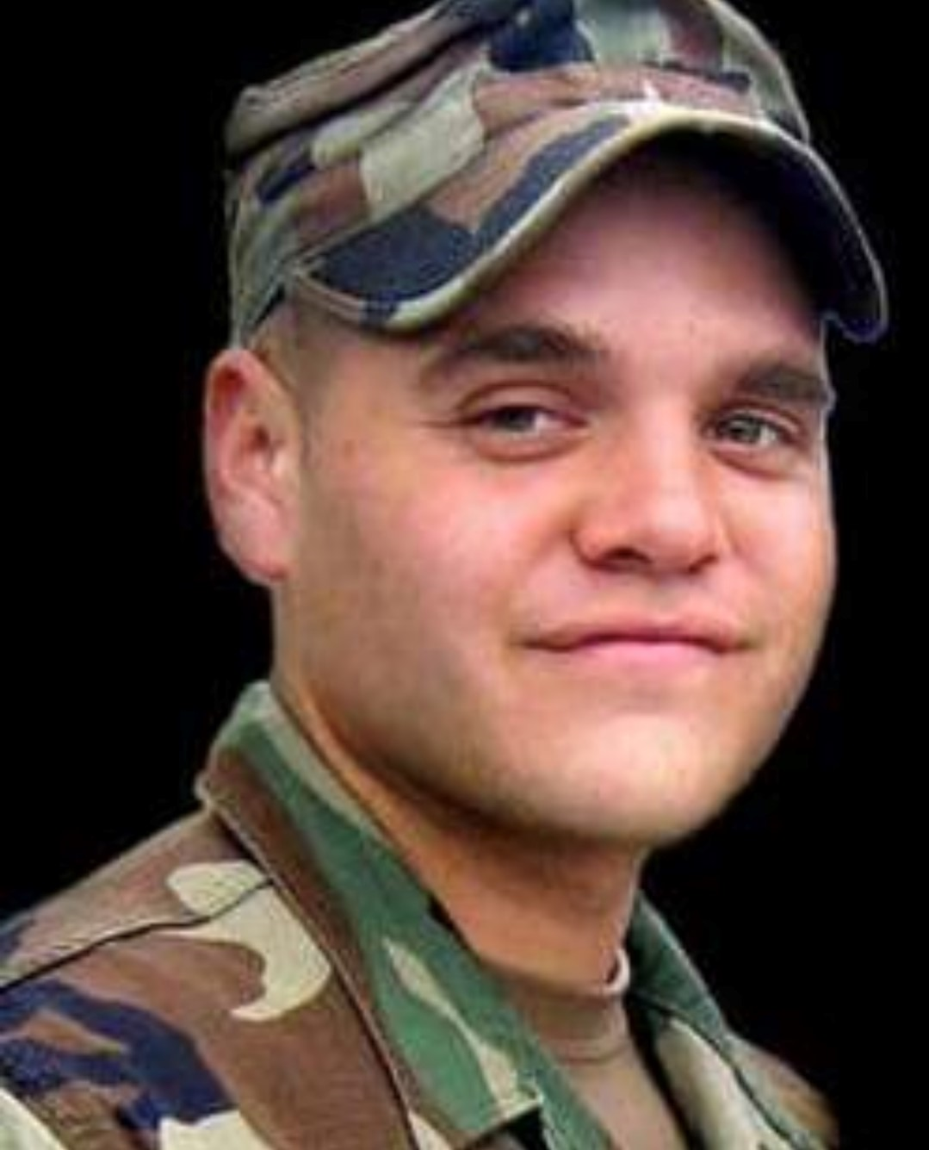
1st Lt. Joshua Deese
Alpha Chapter
Delta Class, Spring 2000
March 26, 1981 – October 15, 2006

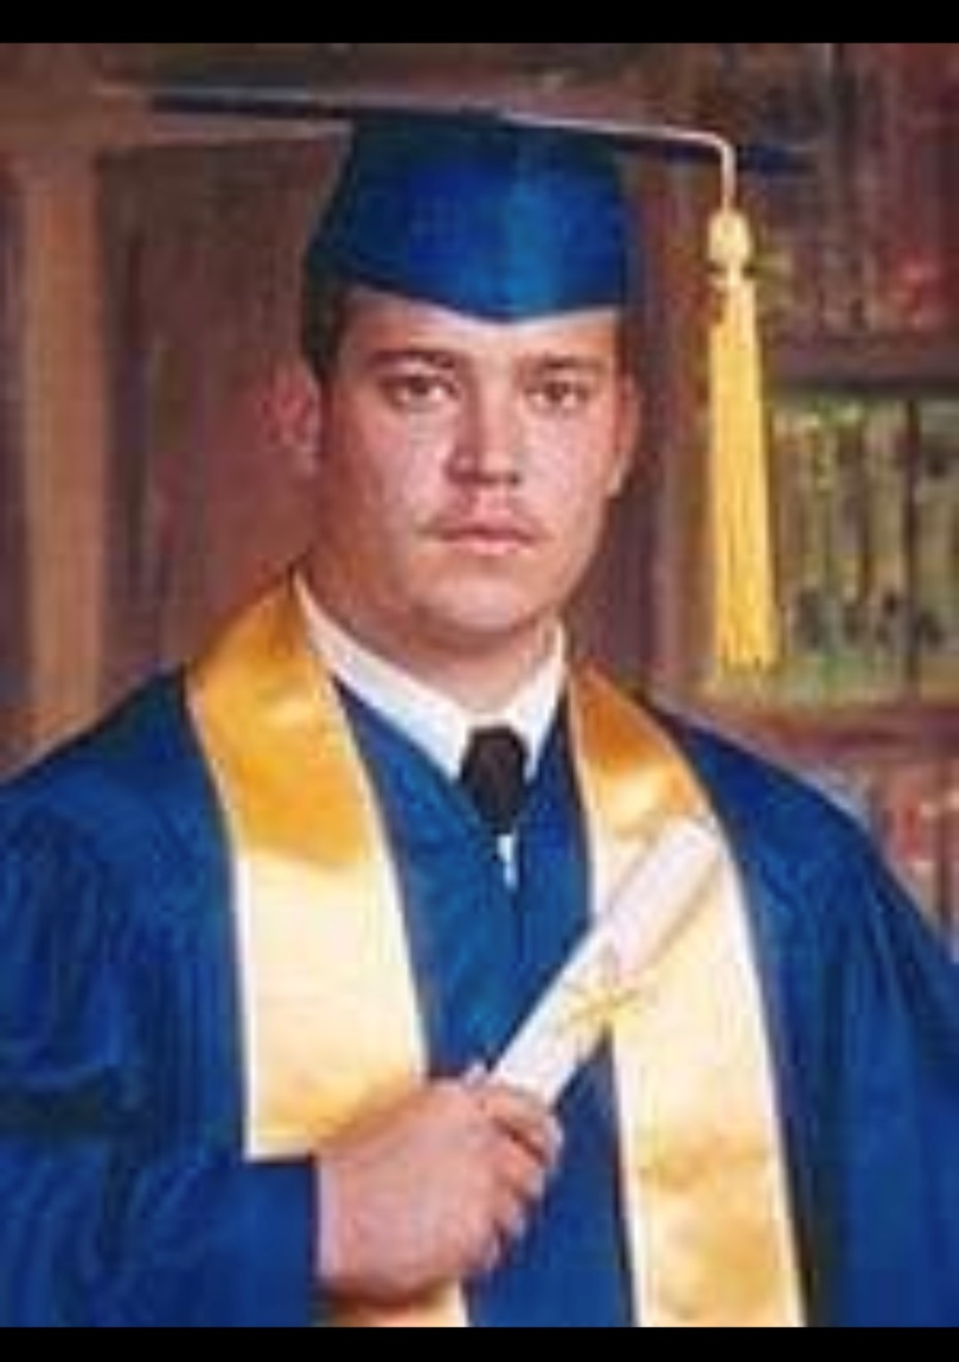
Jason Wayne Hunt
Alpha Chapter
Eta Class, Spring 2002
June 24, 1983 – May 14, 2003

